Class notes
Chapter 6: CONTINUOUS PROBABILITY DISTRIBUTIONS

Section 6.2: The standard normal distribution

Table A-2 gives cumulative areas from the left under the standard normal curve
The Precision Scientific Instrument Company manufactures thermometers that are supposed to give readings of 0 ̊ C at the freezing point of water, some thermometers give readings below 0 ̊ (denoted by negative numbers) and some give readings above 0 ̊ (denoted by positive numbers). Assume that the mean reading is 0 ̊ C and the standard deviation of the readings is 1.00 ̊ C. Also assume that the readings are normally distributed. A thermometer is randomly selected and tested.

#10 p.245.
Find the probability that the reading is less than -2.50

#12 p.245.
Find the probability that the reading is less than 2.50

#14 p.246.
Find the probability that the reading is greater than 1.96

#20 p.246.
Find the probability that the reading is between 1.05 and 2.05

#24 p.246.
Find the probability that the reading is between -3.90 and 1.50

#28 p.246.
Find the probability that the reading is less than 0

Find the indicated probability where z is the reading in degrees.

#34 p.246.
P(z > 1.645)

#36 p.246.
P(z < -1.96 or z >1.96)

Example:
Find the value that separates the bottom 25% from the top 75% (P₂₅ - the 25th percentile). Don’t forget to turn % into decimal form with 4 decimal places

#40 p 206.
If 1.0% of the thermometers are rejected because they have readings that are too high and another 1.0% are rejected because they have readings that are too low. Find the two readings that are cutoff values separating the rejected thermometers from the others.

Section 6.3: Applications of normal distributions

Before using table A-2 convert values to standard scores using the formula $z=\frac{x−μ}{σ}$
Assume that adults have IQ scores that are normally distributed with a mean of 100 and a standard deviation of 15.

#6 p 254.
Find the probability that a randomly selected adult has an IQ greater than 131.5 (the requirement for Mensa organization)

#8 p 254.
Find the probability that a randomly selected adult has an IQ between 110 and 120 (referred to as bright normal)

#10 p 254.
Find P₆₀, which is the IQ score separating the bottom 60% from the top 40%.

#12 p 254.
Find the IQ score separating the top 85% from the others.

#15 p 255. Designing doorways.
Men’s heights are normally distributed with mean 69.0 in. and standard deviation 2.8 in.
Women’s heights are normally distributed with mean 63.6 in. and standard deviation 2.5 in.
The standard doorway height is 80 in.
- What percentage of men are too tall to fit through a standard doorway without bending?

- Based on those results, does it appear that the current doorway design is adequate?

- If a statistician designs a house so that all of the doorways have heights that are sufficient for all men except the tallest 5%, what doorway height would be used?

Section 6.4: Sampling Distributions and Estimators

#8 p.267.
Represent sampling distribution in the format of a table that lists the different values of the sample statistics along with their corresponding probabilities.
Here are the numbers of sales per day that were made by Kim Ryan, a courteous telemarketer who worked four days before fired: 1, 11, 9, 3. Assume that samples of size 2 are randomly selected with replacements from this population of four values.
- List the 16 different possible samples and find the mean of each of them.

- Identify the probability of each sample, then describe the sampling distribution of sample means.

- Find the mean of sampling distribution

- Is the mean of the sampling distribution equal to the mean of the population of the four listed values?

- Is the standard deviation of the sampling distribution equal to the population standard deviation?

#11 p.267.
A genetics experiment involves a population of fruit flies consisting of 1 male named Mike and 3 females named Anna, Barbara, and Chris. Assume that two fruit flies are randomly selected with replacement.
- List all different possible samples and find the proportion of females in each sample.

- Find the mean of a sampling distribution

- Is the mean of the sampling distribution a good estimator of the true proportion of females?

Good (unbiased) estimators: mean, variance, proportion
Bad (biased) estimators: median, range, standard deviation

Section 6.5: The Central Limit Theorem

Given:
- The random variable x has a distribution (which may or may not be normal) with mean µ and standard deviation σ.
- Simple random samples all of size n are selected from the population. (The samples are selected so that all possible samples of the same size n have the same chance of being selected.)

Conclusions:
- The distribution of sample $\bar{x}$ will, as the sample size increases, approach a normal distribution.
- The mean of the sample means is the population mean µ.
- The standard deviation of all sample means is $σ/{\sqrt{n}}$ .

Practical Rules Commonly Used:
- For samples of size n larger than 30, the distribution of the sample means can be approximated reasonably well by a normal distribution. The approximation gets better as the sample size n becomes larger.
- If the original population is itself normally distributed, then the sample means will be normally distributed for any sample size n (not just the values of n larger than 30).

- Women’s heights are normally distributed with a mean of 63.6 in and standard deviation of 2.5 in (based on the data from the National Health Survey)
  - If 1 woman is randomly selected, find the probability that her height is greater than 63 in.

  - If 100 women are randomly selected, find the probability that they have a mean height greater than 63 in

- The average length of a newborn baby is 23.3 inches, with σ = 2.04 inches. Samples of 15 babies are taken.
  - Find the mean and the standard deviation of the sampling distribution.

  - What can be said about the shape of the distribution of the sample means?

  - Reconsider question b) about the shape of the distribution of the sample means when n = 35.

- The scores on a standardized Math Test for 12-year-olds are normally distributed with the mean of 73 and a standard deviation is 7.9. If a sample of 22 12-year-olds is selected, what is the probability that its mean will be between 70 and 75?

  - To answer this question, can we assume that the distribution on the sample means can be approximated by a normal distribution?

  - Answer the question.

- The average life of a battery in a 64-function calculator is 758 hours with standard deviation of 47.8 hours. If a sample of 34 calculators is selected

  - Find the probability that the mean life-time of a battery will be more than 743 hours

  - Below what value will we find the bottom 19% of the sample means?

Try this problem by yourself.
- The amount of coffee dispensed by a vending machine on any given day is normally distributed with the mean of 10.8 oz and standard deviation of 1.29oz. Yesterday 45 cups of coffee were sold.

  - What is the probability that sample mean is more than 11 oz?

  - Find the value that separates the top 88% of sample means.

Section 6.6: Normal Distribution as Approximation to a Binomial Distribution

Example:
Twelve jurors are to be randomly selected from a population in which 80% of the jurors are Mexican-American. If we assume that jurors are randomly selected without bias, and if we let x represent the number of Mexican-American jurors among 12 jurors, we will get a probability distribution represented by the following histogram.
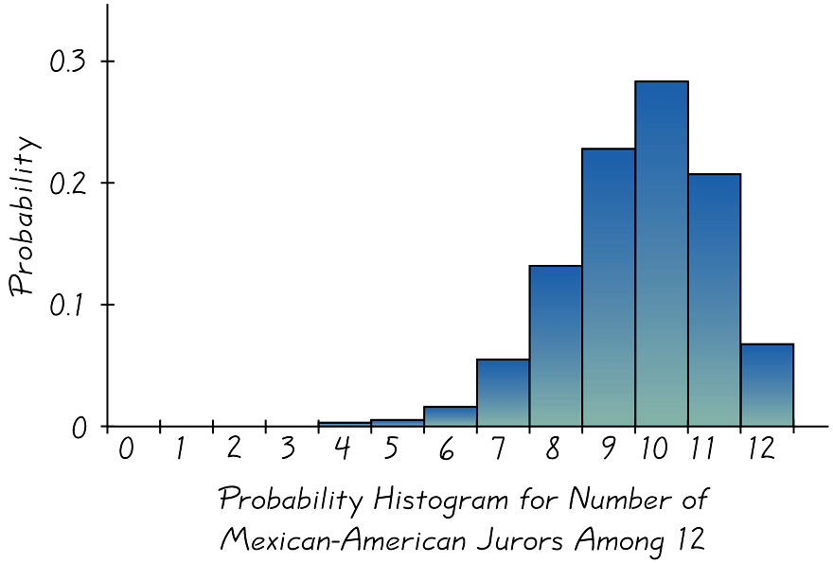

Use the Normal Distribution as approximation to Binomial to find the probability that more than 10 Mexican-American jurors will be selected to serve on the next committee.

Procedure for Using a Normal Distribution to Approximate a Binomial Distribution.

- Establish that the normal distribution is a suitable approximation to the binomial distribution by verifying np ≥ 5 and nq ≥ 5.
- Find the values of the parameters µ and σ by calculating µ = np and σ = npq.
- Identify the discrete value of x (the number of successes). Change the discrete value x by replacing it with the interval from x – 0.5 to x + 0.5. (continuity correction.) Draw a normal curve and enter the values of µ , σ, and either x – 0.5 or x + 0.5, as appropriate.

Use this information to solve the following four problems: The given values are discrete. Use the continuity correction and describe the region of the normal distribution that corresponds to the indicated probability.

#6 p.287.
Probability of at least 12 adult males on an elevator in the Empire State building.

#8 p.287.
Probability that the number of working vending machines in the United States is exactly 27.

#10 p.287.
Probability that the number of incorrect statistical procedures in Excel is between 15 and 20 inclusive.

#12 p.287.
Probability that Exactly employees were fired for inappropriate use of the Internet.

For the problems below estimate the indicated probability by using the normal distribution as an approximation to the binomial distribution.

#18 p.287.
Assuming that boys and girls are equally likely, estimate the probability of getting at least 42 girls in 64 births. Is it unusual to get at least 42 girls in 64 births?

#24 p.288.
Air America is considering a new policy of booking as many as 400 persons on an airplane that can seat only 350. (Past studies have revealed that only 85% of the booked passengers actually arrive for the flight.) Estimate the probability that if Air America books 400 persons, not enough seats will be available. Is that probability low enough to be workable, or should the policy be changed?

#30 p.289.
In Orange County, 12% of those eligible for jury duty are left-handed. Among 250 people selected for jury duty, 25 (10% ) are lefties. Find the probability of getting at most 25 lefties assuming that they are chosen with a process designed to yield a 12% of lefties. Can we conclude that this process of selecting jurors discriminates against lefties?

